Validation Form

- Add validation
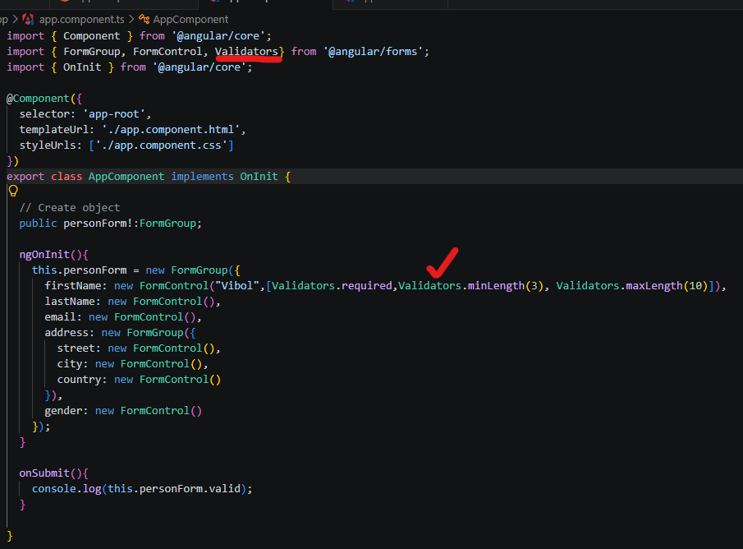

- Import validators
- console.log(this.personForm.valid); if the form valid it will true then it will false.

